PROJECT REPORT

Date | 18 November 2022
Team ID | PNT2022TMID50481
Project name | Real Time communication system Powered by AI for Specially Abled

1.INTRODUCTION:
Speech impaired people use hand signs and gestures to communicate. Normal people face difficulty in understanding their language. Hence there is a need of a system which recognizes the different signs, gestures and conveys the information to the normal people. It bridges the gap between physically challenged people and normal people.

1.1 Project Overview
In this sign language recognition project, we create a sign detector, which detects numbers from 1 to 10 that can very easily be extended to cover a vast multitude of other signs and hand gestures including the alphabets. We have developed this project using OpenCV and koras modules of python.

1.2 Purpose
project uses image processing system to identify, especially English alphabetic sign language used by the deaf people to communicate and converts them into text so that normal people can understand.

2.LITERATURE SURVEY
Communication is a social process of exchanging information from one entity to another inverbal and non-verbal form. It defines our existence and it is an important instrument thatconnects people together. It comes naturally as a raw skill embedded in most people at birth andweacquiredthewaysofcommunicationthroughcognitivelearning.Communicationisthebasis,wh ichdrivestheprocessofdevelopmentinallthefields(Manohar,2008)anditistheverycoreof our civilisation. The ability to communicate allows us to express emotion, feelings, conveyour thoughts and ideas as well as to relate our experiences. It plays an important role in the dissemination of information and sharing of knowledge especially in the academic arena. Researchhas found that human started to learn how to communicate with each other since they are bornnot only through spoken and written languages but also body gesture, posture, facial expressionandeyecontacts(Busso,etal.,2004;Cohen,Grag&Huang,2000). Communicationskillmightcome asanaturalabilityin majorityofpeople.However,therearesome people inflicted with some form of physical defects which affect their ability tocommunicate. One of the more severe disabilities is known as “cerebral palsy”, a congenitaldisorder at birth which causes abnormality in their Motor system. It affects their musclemovement and coordination, learning and Speech abilities. Their malfunctioned motor systemcausesanuncontrollableandinvoluntarymovement.Theyareunabletocontroltheiroralfacial muscles,thusaffectstheirabilitytoperformfacialexpressionappropriately.
From the limitation of the existing tools reviewed (Novita, 2006; Macsolvers, 2009; Standup,2006; Universiteit van Amsterdam, 2008; Crestwood, 2009; Sci-enceDaily, 2008), there is still apressing need for more effective and efficient tools to alleviate this problem. One the possiblemethods are to implement a facial expres-sion recognition system to predict or determine theemotional state of a disabled person through his expression projected on his face. biometricsinformationsystemcanbeemployed asameanstodetectandclassifythephysiologicalaspectofa person in real time. Franco and Treves (2001) further support the notion that facial expressioncanbeusedforhumancomputerinteractionandusabilityenhancement.
Based on the problem statements deliberated above, we propose an improved realtimecommunication system using machine learning and computer vision. The aim is to create acommunicationchannelbetweenthespeciallyabledandthesociety,sotheycanexpresstherefeelings, thoughts and understand other people’s feelings and thoughts through real timecommunicationandfacialexpressions.

2.1 Existing problem
Sign Language recognition is challenged by problems, such as accurate tracking of hand gesture, occlusion of hands, and high computational cost.

2.2 References
Base Paper:
http://cs231n.stanford.edu/reports/2016/pdfs/214_Report.pdf

http://www.iosrjen.org/Papers/vol3_issue2%20(part-2)/H03224551.pdf

Other References:

http://citeseerx.ist.psu.edu/viewdoc/download?doi=10.1.1.734.8389&rep=rep1&typ e=pdf
http://citeseerx.ist.psu.edu/viewdoc/download?doi=10.1.1.734.8389&rep=rep1&typ e=pdf
https://ieeexplore.ieee.org/document/7507939

https://ieeexplore.ieee.org/document/7916786

https://www.sciencedirect.com/science/article/pii/S1877050917320720

https://medium.com/@RaghavPrabhu/understanding-of-convolutional-neural- network-cnn-deep-learning-99760835f148
https://adeshpande3.github.io/adeshpande3.github.io/A-Beginner's-Guide-To- Understanding-Convolutional-Neural-Networks/

2.3 Problem Statement Definition
Dump people use hand signs to communicate, hence normal people face problem in recognizing their language by signs made. Hence there is a need of the systems which recognize the different signs and conveys the information to the normal people.
3.IDEATION & PROPOSED SOLUTION
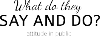
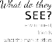
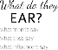
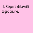
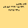
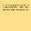

3.1 Empathy Map Canvas
3.2 IDEATION & BRAIN STORMING

Use this template in your own brainstorming sessions so your team can unleash their imagination and start shaping concepts even if you're not sitting in the same room.

Team gathering
Define who should participate in the session and send an invite. Share relevant information or pre-work ahead.

Set the goal
Think about the problem you'll be focusing on solving in the brainstorming session.

Learn how to use the facilitation tools
Use the Facilitation Superpowers to run a happy and productive session.
3.3 PROPOSED SOLUTION
The learning aids for hearing and speech disabled people exist but the usage of these aids are limited.
The proposed system would be a real time system wherein live sign gestures would be a processed using image processing . then classifiers would be used to differentiate various signs and translate output would be displaying text. Machine learning algorithms will be used to train on the data set.
The purpose of the system is to improve the exixting system in this area in terms of response time and accuracy with the use of efficient algorithms, high quality data sets and better sensors. Technologies used Tensor flow , Keras, OpenCv
3.4 PROBLEM SOLUTION FIT
The goal of the paper is reviewing several aspects of Sign language Recognition problems focusing on Artificial Neural Network approach.the lack of automated Latvian Sign language has identified and proposals of how to develop such a system have made. The authors use analytical , statistical methods as well as practical experiments with neural network software.

4.REQUIREMENT ANALYSIS

4.1 Functional Requirement

Product Perspective
The product should be light weight and mobile. The sensors are sewn onto a glove which makes the product cost effective as well.
The product includes a bluetooth module which would be able to wirelessly connect to a mobile device to display the text on in an easier manner.

Product features
- BLE Technology
It is a wireless PAN technology that allows us to use extremely low power require- ment while maintaining similar coverage range as traditional bluetooth technology. It is typically used in smart technologies such as fitbits and wearables that communicate with mobile phones. It also has a large compatibility with a large range of mobile phones, tablets and computers. Devices using BLE have a longer lifespan due to low
power requirement giving their average lifetime to span over months or years. The power source also is extremely cheap and hence makes devices low cost and smaller in size. BLE allows users to transmit smaller amounts of data over periodic intervals of time.

- Power Source
The device uses a very light battery, a coin cell. Since the system uses BLE which has very low power consumption it works on coin cells thereby reducing the cost of the system and making the system extremely light.

User characteristics
Software Requirements and Alerts- The mobile phone owner is the end user. Whenev- er the deaf/mute person communicates using sign, every 10s the data from the glove is sent via bluetooth to the mobile phone. An android application translates and prints the text onto the screen.

Assumption & Dependencies
- The user is assumed to have a fully functioning hand with five fingers.
- The user is assumed to be right handed.
- The user is assumed to know ASL for all 26 alphabets.
- The end user is assumed to not be blind.
- Palm size of the user is assumed to be the standard palm size index.
- The end user is assumed to be an android user
- The messages that are sent across are short and concise

Domain Requirements
- Collection of data on the various types of sign language, in particular ASL.
- Assistance and support of an experienced sign language translator.

User Requirements
- The user needs to know ASL.
- The messages that need to be sent have to short and basic.
- Device needs to be handled with care.
- Device should malfunction and give electrical shocks

4.2.Non Functional Requirements

Product Requirements Efficiency
The system is extremely efficient in terms of performance, throughput and cost. The cost effective nature of the system makes it extremely liable and thus, efficient. The idea of making this system compact was to strive away from overhead costs. The storage requirement is very less (It has to store only 35 signs).
Reliability
The system is very reliable, it can last for long amounts of time if well maintained. The flex sensors have a good lifespan if used carefully. The battery is the only part of the device which has to be replaced often as it is a coin cell which doesn’t have a lot of power.

Portability
The device is a wearable portable glove that contain sensors and hence is extremely portable. The device is wireless and is light in weight and can be carried around easi- ly. It is device friendly working on any android phone.

Usability
It caters to a very niche crowd of the educated deaf or dumb people, which is around
12.3 million people (in India alone). The usability of the system is quite universal, to say the least. A whole array of people can be made comfortable to use this system as it’s extremely easy to use and operate. The glove is a wearable which can be easily used by all age groups.
51.DataflowDiagram
The DFD is also known as bubble chart. It is a simple graphical formalism thatcan be used to represent a system in terms of the input data to the system, variousprocessing carried out on these data, and the output data is generated by the system. Itmaps out the flow of information for any process or system, how data is processed interms of inputs and outputs. It uses defined symbols like rectangles, circles and arrowsto show data inputs, outputs, storage points and the routes between each destination.They can be used to analyse an existing system or model of a new one. A DFD canoftenvisually“say” things that
wouldbehardtoexplaininwordsandtheyworkforbothtechnicalandnon-technical.TherearefourcomponentsinDFD:
ExternalEntity
Process
DataFlow
dataStore
ExternalEntity:
It is an outside system that sends or receives data, communicating with the system.They are the sources and destinations of information entering and leaving the system.They might be an outside organization or person, a computer system or a businesssystem. They are known as terminators, sources and sinks or actors. They are typicallydrawn on the edges of the diagram. These are sources and destinations of the system’sinputandoutput.
Representation:
Process:
It is just like a function that changes the data, producing an output. It might performcomputationsfor sortdata based on logic ordirect the dataflowbased on businessrules.
Representation:
DataFlow:
A dataflow represents a package of information flowing between two objects in thedata-flow diagram, Data flows are used to model the flow of information into thesystem,outofthesystemandbetweentheelementswithinthesystem.
Representation:

DataStore:
Thesearethefilesorrepositoriesthatholdinformationforlateruse,suchasadatabasetableoramembershipform.Eachdatastorereceivesasimplelabel.
Representation:
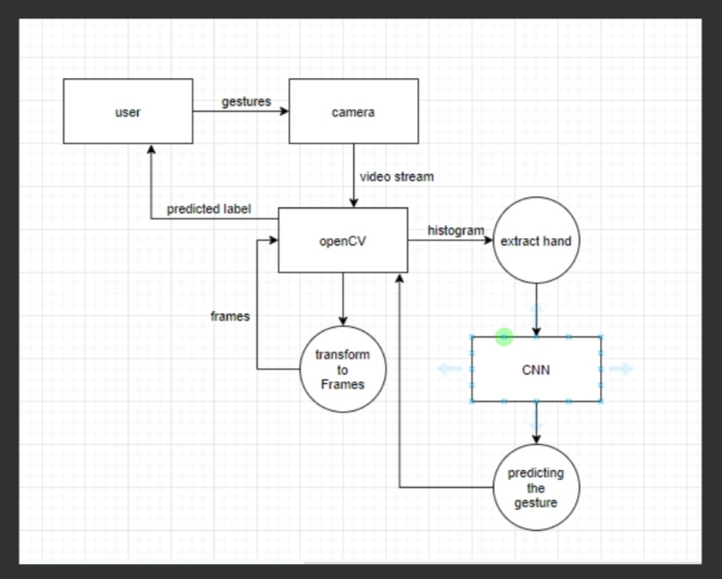
Fig5.1:DataflowDiagramforSignLanguageRecognition
5.2.SOLUTION & TECHNICAL ARCHITECTURE
Real-time communication service architecture
Real-time communication service architecture diagram:
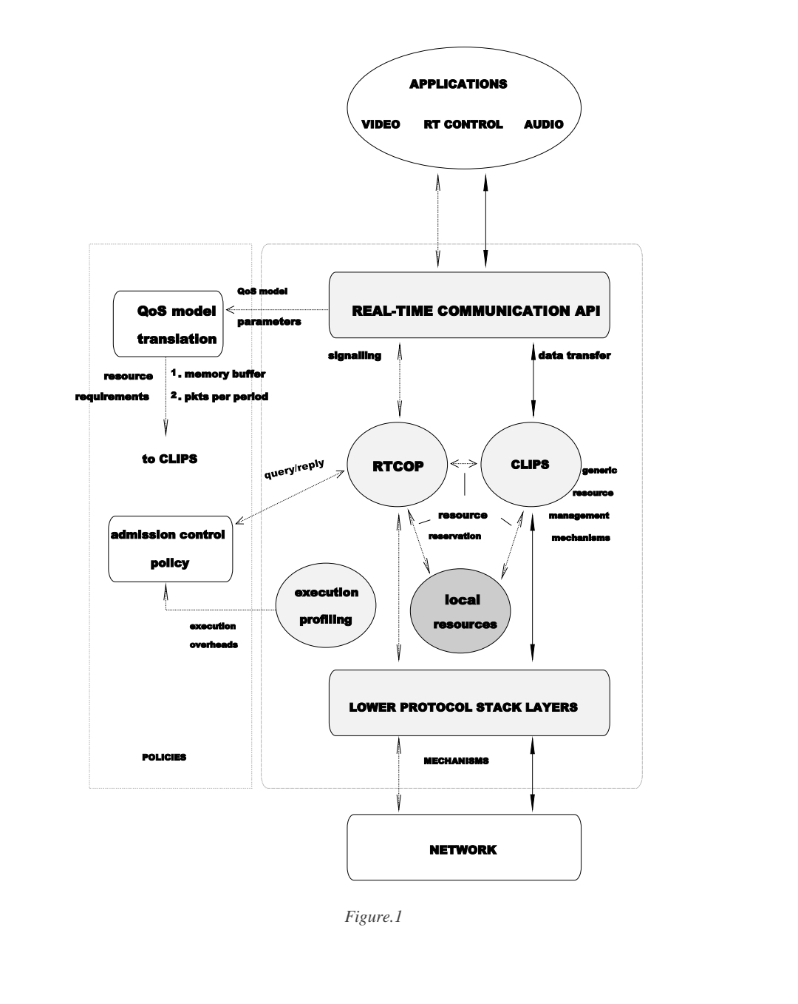
Real-time communication service
architecture: Our implementation consists of
four primary architecturalcomponents: an
application programming interface (RTC API), a
signaling and resource reservation
protocol(RTCOP), supportfor resource
managementand run-time data transfer (CLIPS),
and executionprofiling support. Dashed lines
indicate interactions on the control path while the
data path is denoted by the solid lines

6.PROJECT PLANNING & SCHEDULEING

6.1.SPRINT PLANNING AND ESTIMATION

The 2011 Indian census cites roughly 1.3 million people with “hearingimpairment”. Incontrast to that numbers from India’s National Association of the Deafestimates that18 million people –roughly 1 per cent of Indian population are deaf. These statisticsformed the motivation for our project. As these speech impairment and deaf people need a proper channel tocommunicatewith normal people thereis a need for a system .Notallnormalpeoplecanunderstandsignlanguageofimpairedpeople.Our
Project hence is aimed atconverting the sign language gestures into text thatisreadablefornormalpeople.

6.2 SPRINT DELIVERY SCHEDULE

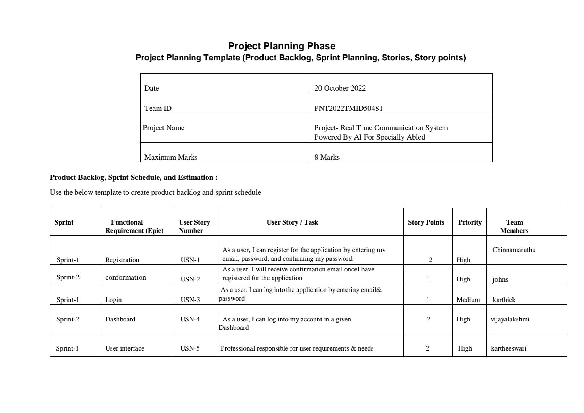
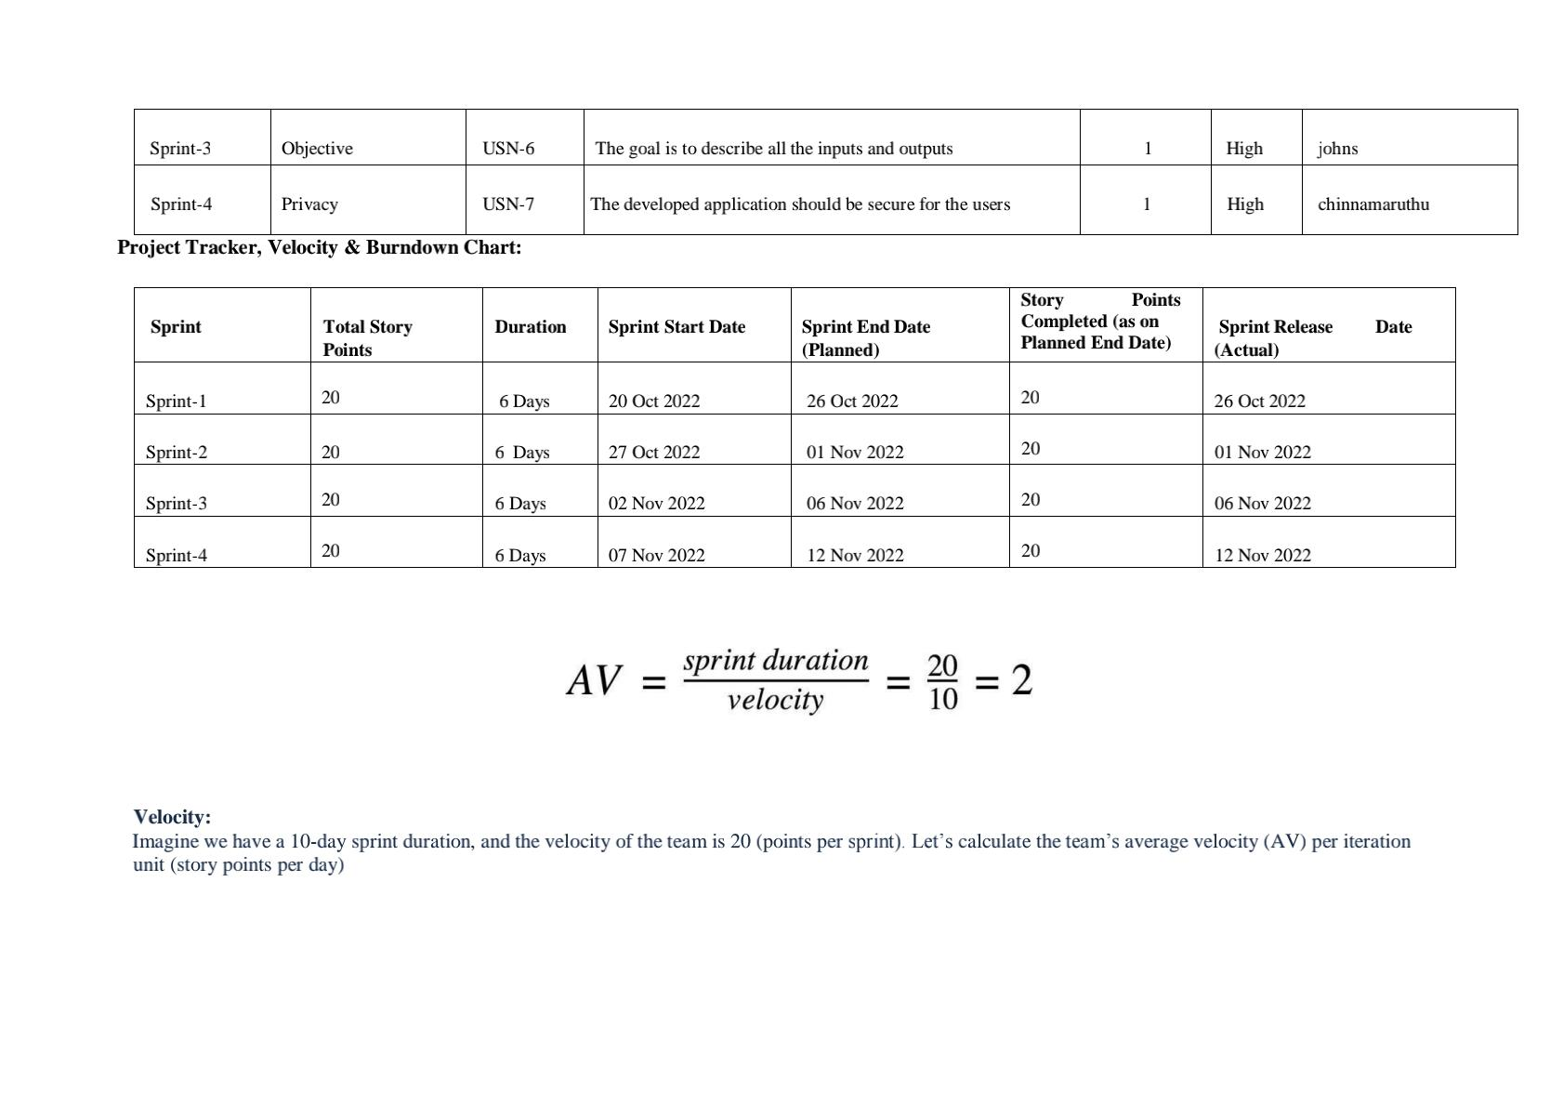
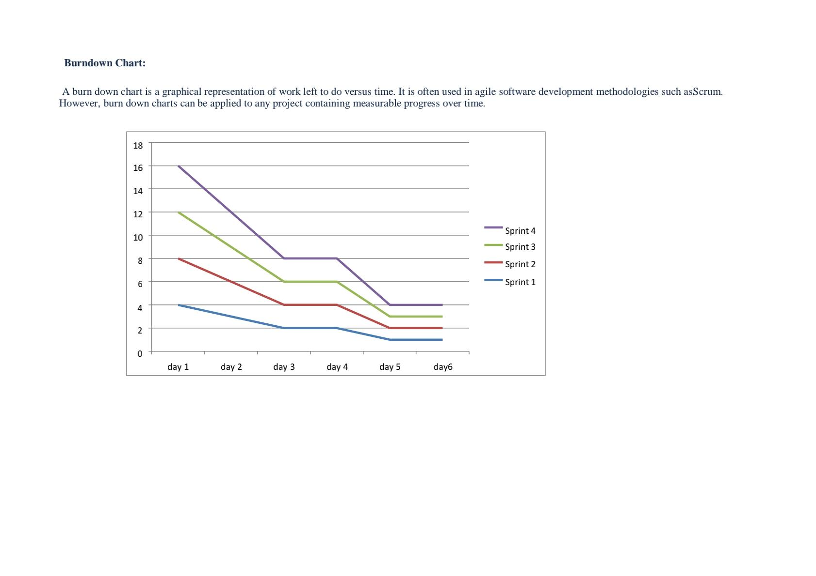
7.CODING & SOLUTION

5.2 CODE

HandExtractor.py
import cv2
import numpy as np
from keras.models import load_model from keras.preprocessing import image import time

labels_dict = {'A': 0, 'B': 1, 'C': 2, 'D': 3, 'E': 4, 'F': 5, 'G': 6, 'H': 7, 'I': 8, 'J': 9, 'K': 10,
'L': 11, 'M': 12,
'N': 13, 'O': 14, 'P': 15, 'Q': 16, 'R': 17, 'S': 18, 'T': 19, 'U': 20, 'V': 21, 'W': 22,
'X': 23, 'Y': 24,
'Z': 25, 'space': 26, 'del': 27, 'nothing': 28}

_labels = dict([(value, key) for key, value in labels_dict.items()])
img_width, img_height = 64, 64 model = load_model('model.h5')
model.compile(loss='binary_crossentropy', optimizer='rmsprop',
metrics=['accuracy'])

hand_hist = None traverse_point = [] total_rectangle = 9 hand_rect_one_x = None hand_rect_one_y = None

hand_rect_two_x = None hand_rect_two_y = None

defgetPaddedImage(img):

#Getting the bigger side of the image s = max(img.shape[0:2])

#Creating a dark square with NUMPY f = np.zeros((s, s, 3), np.uint8)

#Getting the centering position
ax, ay = (s - img.shape[1])//2, (s - img.shape[0])//2

#Pasting the 'image' in a centering position f[ay:img.shape[0]+ay, ax:ax+img.shape[1]] = img return f

defrescale_frame(frame, wpercent=130, hpercent=130): width = int(frame.shape[1] * wpercent / 100)
height = int(frame.shape[0] * hpercent / 100)
return cv2.resize(frame, (width, height), interpolation=cv2.INTER_AREA)

def contours(hist_mask_image):
gray_hist_mask_image = cv2.cvtColor(hist_mask_image, cv2.COLOR_BGR2GRAY) ret, thresh = cv2.threshold(gray_hist_mask_image, 0, 255, 0)
_, cont, hierarchy = cv2.findContours(thresh, cv2.RETR_TREE, cv2.CHAIN_APPROX_SIMPLE)
return cont

defmax_contour(contour_list): max_i = 0
max_area = 0

for i in range(len(contour_list)): cnt = contour_list[i]

area_cnt = cv2.contourArea(cnt)

if area_cnt>max_area: max_area = area_cnt max_i = i

return contour_list[max_i]

defdraw_rect(frame):
rows, cols, _ = frame.shape
global total_rectangle, hand_rect_one_x, hand_rect_one_y, hand_rect_two_x, hand_rect_two_y

hand_rect_one_x = np.array(
[6 * rows / 20, 6 * rows / 20, 6 * rows / 20, 9 * rows / 20, 9 * rows / 20, 9 * rows
/ 20, 12 * rows / 20,
12 * rows / 20, 12 * rows / 20], dtype=np.uint32)

hand_rect_one_y = np.array(
[9 * cols / 20, 10 * cols / 20, 11 * cols / 20, 9 * cols / 20, 10 * cols / 20, 11 * cols
/ 20, 9 * cols / 20,
10 * cols / 20, 11 * cols / 20], dtype=np.uint32)

hand_rect_two_x = hand_rect_one_x + 10 hand_rect_two_y = hand_rect_one_y + 10

for i in range(total_rectangle):
cv2.rectangle(frame, (hand_rect_one_y[i], hand_rect_one_x[i]), (hand_rect_two_y[i], hand_rect_two_x[i]),
(0, 255, 0), 1)

return frame

defhand_histogram(frame):
global hand_rect_one_x, hand_rect_one_y

hsv_frame = cv2.cvtColor(frame, cv2.COLOR_BGR2HSV)

roi = np.zeros([90, 10, 3], dtype=hsv_frame.dtype)

for i in range(total_rectangle):
roi[i * 10: i * 10 + 10, 0: 10] = hsv_frame[hand_rect_one_x[i]:hand_rect_one_x[i] +
10,
hand_rect_one_y[i]:hand_rect_one_y[i] + 10]

hand_hist = cv2.calcHist([roi], [0, 1], None, [180, 256], [0, 180, 0, 256])
return cv2.normalize(hand_hist, hand_hist, 0, 255, cv2.NORM_MINMAX)

defhist_masking(frame, hist):
hsv = cv2.cvtColor(frame, cv2.COLOR_BGR2HSV)
dst = cv2.calcBackProject([hsv], [0, 1], hist, [0, 180, 0, 256], 1)

disc = cv2.getStructuringElement(cv2.MORPH_ELLIPSE, (31, 31)) cv2.filter2D(dst, -1, disc, dst)

ret, thresh = cv2.threshold(dst, 150, 255, cv2.THRESH_BINARY) thresh = cv2.dilate(thresh, None, iterations=5)
thresh = cv2.merge((thresh, thresh, thresh)) return cv2.bitwise_and(frame, thresh)

def centroid(max_contour):
moment = cv2.moments(max_contour) if moment['m00'] != 0:
cx = int(moment['m10'] / moment['m00']) cy = int(moment['m01'] / moment['m00']) return cx, cy
else:

return None

deffarthest_point(defects, contour, centroid):
if defects is not None and centroid is not None: s = defects[:, 0][:, 0]
cx, cy = centroid

x = np.array(contour[s][:, 0][:, 0], dtype=np.float)
y = np.array(contour[s][:, 0][:, 1], dtype=np.float)

xp = cv2.pow(cv2.subtract(x, cx), 2) yp = cv2.pow(cv2.subtract(y, cy), 2) dist = cv2.sqrt(cv2.add(xp, yp))

dist_max_i = np.argmax(dist)

if dist_max_i<len(s): farthest_defect = s[dist_max_i]
farthest_point = tuple(contour[farthest_defect][0]) return farthest_point
else:
return None

defdraw_circles(frame, traverse_point): if traverse_point is not None:
for i in range(len(traverse_point)):
cv2.circle(frame, traverse_point[i], int(5 - (5 * i * 3) / 100), [0, 255, 255], -1)

defgetHand_Rect(frame, hand_hist):
_frame_copy=frame.copy()
hist_mask_image = hist_masking(frame, hand_hist)

# cv2.imshow('hist masked', hist_mask_image) contour_list = contours(hist_mask_image) max_cont = max_contour(contour_list)
print(max_cont.shape,"shapre") cnt_centroid = centroid(max_cont)
cv2.circle(frame, cnt_centroid, 5, [255, 0, 255], -1)
cv2.drawContours(frame, max_cont, -1, (255,0, 0), 3) tolarence=30
height, width, _ = frame.shape if max_cont is not None:
x, y, w, h = cv2.boundingRect(max_cont) x = max(0, x-tolarence)
y= max(0,y-tolarence)
w = min(w+tolarence, width) h=min(h+tolarence,height)
roi = _frame_copy[y:y+h, x:x+w]
processed_img = cv2.resize(getPaddedImage(roi), (64, 64)) # cv2.imshow('test', processed_img)
return processed_img return None

defextractSkin(image):
# Taking a copy of the image img = image.copy()
# Converting from BGR Colours Space to HSV img = cv2.cvtColor(img, cv2.COLOR_BGR2HSV)

# Defining HSV Threadholds
lower_threshold = np.array([0, 48, 80], dtype=np.uint8)
upper_threshold = np.array([20, 255, 255], dtype=np.uint8)

# Single Channel mask,denoting presence of colours in the about threshold skinMask = cv2.inRange(img, lower_threshold, upper_threshold)

# Cleaning up mask using Gaussian Filter skinMask = cv2.GaussianBlur(skinMask, (3, 3), 0)

# Extracting skin from the threshold mask
skin = cv2.bitwise_and(img, img, mask=skinMask)

# Return the Skin image
return cv2.cvtColor(skin, cv2.COLOR_HSV2BGR)

defmain():
global hand_hist is_hand_hist_created = False
capture = cv2.VideoCapture(0)

while capture.isOpened(): pressed_key = cv2.waitKey(1)
_, frame = capture.read()
_frame_copy=frame
if pressed_key& 0xFF == ord('z'): is_hand_hist_created = True
hand_hist = hand_histogram(frame)

if is_hand_hist_created:
extracted_hand_image = getHand_Rect(frame, hand_hist) if(extracted_hand_image is not None):
# foreground_hand = extractSkin(extracted_hand_image) # cv2.imshow('masked', foreground_hand)
x = image.img_to_array(extracted_hand_image) x = np.expand_dims(x, axis=0)

images = np.vstack([x])
classes = model.predict_classes(images, batch_size=10)

print("predictions : ",classes)
print("predicted label : ",_labels.get(classes[0]))
cv2.putText(frame, _labels.get(classes[0]), (300, 300),
cv2.FONT_HERSHEY_SIMPLEX, 2, (255, 0, 0), 2, cv2.LINE_AA)
else:
frame = draw_rect(frame)
cv2.imshow("Live Feed", rescale_frame(frame)) if pressed_key == 27:
break

cv2.destroyAllWindows() capture.release()

if name == ' main ':
main()

model.py

from keras.preprocessing import image from keras.models import load_model import numpy as np
import pandas as pd import os
import keras
from keras.layers import Conv2D, MaxPool2D, Flatten, Dense, Dropout,
BatchNormalization
from keras.preprocessing.image import ImageDataGenerator from keras.models import Sequential
# from tensorflow.keras.models import Sequential from keras import regularizers

from sklearn.model_selection import train_test_split import cv2
import matplotlib.pyplot as plt import seaborn as sns

train_dir = './dataset/asl-alphabet_exclude/asl_alphabet_train/asl_alphabet_train' test_dir = './dataset/asl-alphabet_exclude/asl_alphabet_test/asl_alphabet_test'

# **Plotting one image from each class :** defload_unique():
size_img = 64, 64 images_for_plot = [] labels_for_plot = []
for folder in os.listdir(train_dir):
for file in os.listdir(train_dir + '/' + folder): filepath = train_dir + '/' + folder + '/' + file
print(filepath)
image = cv2.imread(filepath) final_img = cv2.resize(image, size_img)
final_img = cv2.cvtColor(final_img, cv2.COLOR_BGR2RGB) images_for_plot.append(final_img) labels_for_plot.append(folder)
break
return images_for_plot, labels_for_plot

images_for_plot, labels_for_plot = load_unique() print("unique_labels = ", labels_for_plot)

fig = plt.figure(figsize=(15, 15))

defplot_images(fig, image, label, row, col, index): fig.add_subplot(row, col, index)
plt.axis('off') plt.imshow(image) plt.title(label)
return

image_index = 0
row = 5
col = 6
for i in range(1, (row*col)):
plot_images(fig, images_for_plot[image_index], labels_for_plot[image_index], row, col, i) image_index = image_index + 1
plt.show()

# **LOADING DATA**

# 5. creating training and test data by splitting original data into 95% of training data and 5% testing data.

# 1. Defining a dictionary which contains labels and its mapping to a number which acts as class label.;
labels_dict = {'A': 0, 'B': 1, 'C': 2, 'D': 3, 'E': 4, 'F': 5, 'G': 6, 'H': 7, 'I': 8, 'J': 9, 'K': 10,
'L': 11, 'M': 12,
'N': 13, 'O': 14, 'P': 15, 'Q': 16, 'R': 17, 'S': 18, 'T': 19, 'U': 20, 'V': 21, 'W': 22,
'X': 23, 'Y': 24,
'Z': 25, 'space': 26, 'del': 27, 'nothing': 28}

# 2. loading image data and labels and then mapping those labels to the dictionary defined before.

defload_data(): """
Loads data and preprocess. Returns train and test data along with labels. """
images = [] labels = [] size = 64, 64
print("LOADING DATA FROM : ", end="")
for folder in os.listdir(train_dir): print(folder, end=' | ')
for image in os.listdir(train_dir + "/" + folder): temp_img = cv2.imread(train_dir + '/' + folder + '/' + image) temp_img = cv2.resize(temp_img, size) images.append(temp_img) labels.append(labels_dict[folder])

images = np.array(images)
# 3. Normalizing image data.
images = images.astype('float32')/255.0 # 4. converting labels to one hot format. labels = keras.utils.to_categorical(labels)

X_train, X_test, Y_train, Y_test = train_test_split( images, labels, test_size=0.05)

print()
print('Loaded', len(X_train), 'images for training,', 'Train data shape =', X_train.shape)
print('Loaded', len(X_test), 'images for testing', 'Test data shape =', X_test.shape)

return X_train, X_test, Y_train, Y_test

X_train, X_test, Y_train, Y_test = load_data()

# **DEFINING MODEL**

defcreate_model(): model = Sequential()
model.add(Conv2D(16, kernel_size=[
3, 3], padding='same', activation='relu', input_shape=(64, 64, 3)))
model.add(Conv2D(32, kernel_size=[3, 3],
padding='same', activation='relu')) model.add(MaxPool2D(pool_size=[3, 3]))

model.add(Conv2D(32, kernel_size=[3, 3],
padding='same', activation='relu')) model.add(Conv2D(64, kernel_size=[3, 3],
padding='same', activation='relu')) model.add(MaxPool2D(pool_size=[3, 3]))

model.add(Conv2D(128, kernel_size=[3, 3], padding='same', activation='relu'))
model.add(Conv2D(256, kernel_size=[3, 3], padding='same', activation='relu'))
model.add(MaxPool2D(pool_size=[3, 3])) model.add(BatchNormalization())
model.add(Flatten()) model.add(Dropout(0.5)) model.add(Dense(512, activation='relu', kernel_regularizer=regularizers.l2(0.001)))

model.add(Dense(29, activation='softmax'))

model.compile(optimizer='adam',
loss=keras.losses.categorical_crossentropy, metrics=["accuracy"])

print("MODEL CREATED")
model.summary() return model

deffit_model():
model_hist = model.fit(X_train, Y_train, batch_size=64,
epochs=5, validation_split=0.1) return model_hist

# **COMPILING THE MODEL AND FITTING THE TRAINING DATA**

model = create_model() curr_model_hist = fit_model()

# **Plotting the model performance metrics to check model performance.**

plt.plot(curr_model_hist.history['acc']) plt.plot(curr_model_hist.history['val_acc']) plt.legend(['train', 'test'], loc='lower right') plt.title('accuracy plot - train vs test') plt.xlabel('epoch')
plt.ylabel('accuracy') plt.show()

plt.plot(curr_model_hist.history['loss']) plt.plot(curr_model_hist.history['val_loss']) plt.legend(['training loss', 'validation loss'], loc='upper right') plt.title('loss plot - training vs vaidation')
plt.xlabel('epoch') plt.ylabel('loss') plt.show()

# **EVALUATING THE TRAINED MODEL ON THE TEST DATA SPLIT **

evaluate_metrics = model.evaluate(X_test, Y_test) print("\nEvaluation Accuracy = ", "{:.2f}%".format(
evaluate_metrics[1]*100), "\nEvaluation loss = ", "{:.6f}".format(evaluate_metrics[0]))

# Loading the test data Provided.
# * The test data contains images with the image name as the class, to which the image belongs to.
# * we will load the data and check if the predition is correct for the image.

defload_test_data(): images = [] names = []
size = 64, 64
for image in os.listdir(test_dir):
temp = cv2.imread(test_dir + '/' + image) temp = cv2.resize(temp, size)
images.append(temp) names.append(image)
images = np.array(images)
images = images.astype('float32')/255.0 return images, names

test_images, test_img_names = load_test_data()

# make predictions on an image and append it to the list (predictions).
predictions = [model.predict_classes(image.reshape(1, 64, 64, 3))[0] for image in test_images]

defget_labels_for_plot(predictions):
predictions_labels = []
for i in range(len(predictions)): for ins in labels_dict:
if predictions[i] == labels_dict[ins]: predictions_labels.append(ins)
break
return predictions_labels

predictions_labels_plot = get_labels_for_plot(predictions)

# PLOTTING THE TEST DATA ALONG WITH THE PREDICTION MADE BY THE MODEL

predfigure = plt.figure(figsize=(13, 13))

def plot_image_1(fig, image, label, prediction, predictions_label, row, col, index): fig.add_subplot(row, col, index)
plt.axis('off') plt.imshow(image)

title = "prediction : [" + str(predictions_label) + "] " + "\n" + label plt.title(title)
return

image_index = 0
row = 5
col = 6
for i in range(1, (row*col-1)):
plot_image_1(predfigure, test_images[image_index], test_img_names[image_index],
predictions[image_index], predictions_labels_plot[image_index], row, col,
i)
image_index = image_index + 1 plt.show()

# As we can see the predictions are correct for almost all the images. Thus the model performs well on the test set.

# testing model with pretrainded model

#testing model
img_width, img_height = 64, 64 model = load_model('model.h5')
model.compile(loss='binary_crossentropy', optimizer='rmsprop', metrics=['accuracy'])

img = image.load_img('A_resized.jpg', target_size=(img_width, img_height)) x = image.img_to_array(img)
x = np.expand_dims(x, axis=0) images = np.vstack([x])

classes = model.predict_classes(images, batch_size=10) print(classes)

8.TESTING

The purpose of testing is to discover errors. Testing is a process of trying to discover every conceivable fault or weakness in a work product.
It provides a way to check the functionality of components, sub assemblies, assemblies and/or a finished product. It is the process of exercising software with the intent of ensuring that the software system meets its requirements and user expectations and does not fail in an unacceptable manner.
Software testing is an important element of the software quality assurance and represents the ultimate review of specification, design and coding. The increasing feasibility of software as a system and the cost associated with the software failures are motivated forces for well planned through testing.

Testing Objectives:
There are several rules that can serve as testing objectives they are:
    - Testing is a process of executing program with the intent of finding an error.
    - A good test case is the one that has a high probability of finding an undiscovered error.

Types of Testing:
In order to make sure that the system does not have errors, the different levels of testing strategies that are applied at different phases of software development are :

Unit Testing:
Unit testing is done on individual models as they are completed and becomes executable. It is confined only to the designer's requirements. Unit testing is different from and should be preceded by other techniques, including:
    - Inform Debugging
    - Code Inspection

Black Box testing
In this strategy some test cases are generated as input conditions that fully execute all functional requirements for the program.
This testing has been used to find error in the following categories: Incorrect or missing functions
    - Interface errors
    - Errors in data structures are external database access
    - Performance error
    - Initialisation and termination of errors
    - In this testing only the output is checked for correctness
    - The logical flow of data is not checked

White Box testing
In this the test cases are generated on the logic of each module by drawing flow graphs of that module and logical decisions are tested on all the cases.
It has been used to generate the test cases in the following cases:
    - Guarantee that all independent paths have been executed
    - Execute all loops at their boundaries and within their operational bounds.
    - Execute internal data structures to ensure their validity.

Integration Testing
Integration testing ensures that software and subsystems work together a whole. It test the interface of all the modules to make sure that the modules behave properly when integrated together. It is typically performed by developers, especially at the lower, module to module level. Testers become involved in higher levels

System Testing

Involves in house testing of the entire system before delivery to the user. The aim is to satisfy the user the system meets all requirements of the client’s specifications. It is conducted by the testing organization if a company has one. Test data may range from and generated to production.
Requires test scheduling to plan and organize:

    - Inclusion of changes/fixes.
    - Test data to use

One common approach is graduated testing: as system testing progresses and (hopefully) fewer and fewer defects are found, the code is frozen for testing for increasingly longer time periods.

Acceptance Testing

It is a pre-delivery testing in which entire system is tested at client’s site on real world data to find errors.
User Acceptance Test (UAT)

“Beta testing”: Acceptance testing in the customer environment.

Requirements traceability:

    - Match requirements to test cases.
    - Every requirement has to be cleared by at least one test case.
    - Display in a matrix of requirements vs. test cases.

Id | Test case | Input description | Expected output | Test status
1 | Loadind model | Initializing trained model and load it into ON | Loaded model without errors | pass
2 | Converting video to frames | Capturing video and converting it into frames | Image frames of captured video stream | pass
3 | Recognize hand gesture | Image frame that contains hand object | label | Pass

9.RESULTS

SCREENSHOTS OF RESULTS
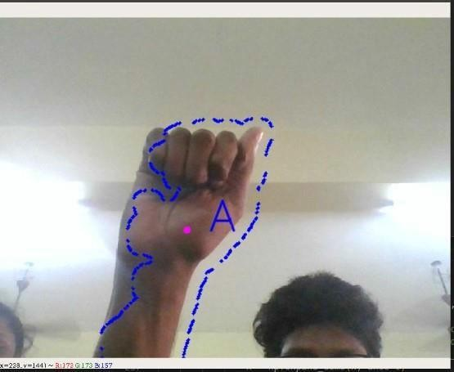
Fig5.1: Screenshot of the result obtained for letter A
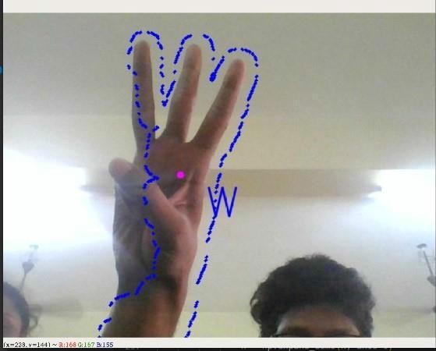
Fig5.2: Screenshot of the result obtained for letter W
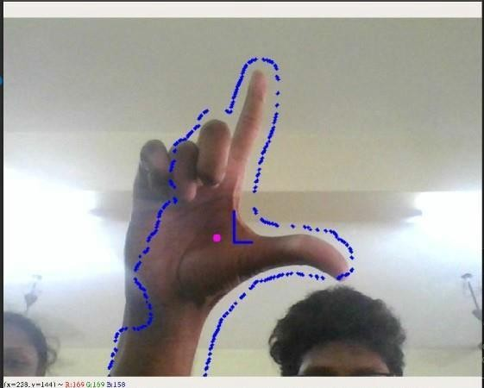

Fig5.3: Screenshot of result obtained for letter L

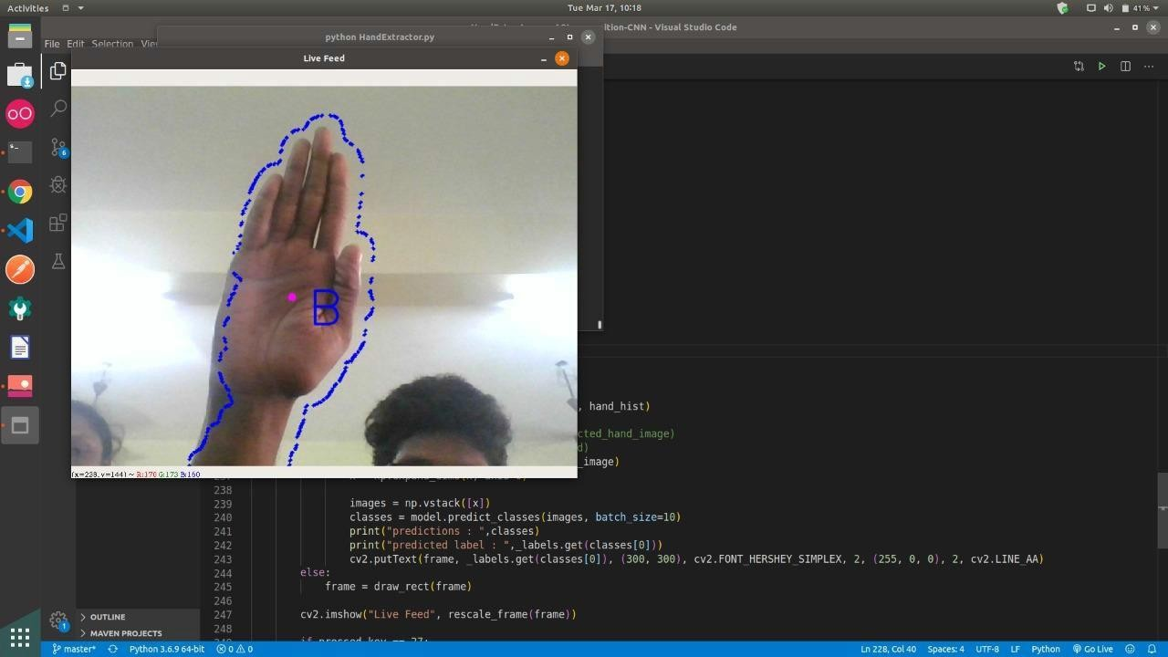

10.ADVANTAGES AND DISADVANTAGES
Sign language allows deaf and hard of hearing people to communicate quickly and effectively with others who use sign language or who ‘’sign’’.
11.CONCULSION:
Nowadays, applications need several kinds of images as sources of information for elucidation and analysis. Several features are to be extracted so as to perform various applications. When an image is transformed from one form to another such as digitizing, scanning, and communicating, storing, etc. degradation occurs. Therefore
,the output image has to undertake a process called image enhancement, which contains of a group of methods that seek to develop the visual presence of an image. Image enhancement is fundamentally enlightening the interpretability or awareness of information in images for human listeners and providing better input for other automatic image processing systems. Image then undergoes feature extraction using various methods to make the image more readable by the computer.Sign language recognition system is a powerful tool to preparae an expert knowledge, edge detect and the combination of inaccurate information from different sources.
\the intend of convolution neural network is to get the appropriate classification

12.FUTURE SCOPE
The proposed sign language recognition system used to recognize sign language letters can be further extended to recognize gestures facial expressions. Instead of displaying letter labels it will be more appropriate to display sentences as more appropriate translation of language.This also increases readability.The scope of different sign languages can be increased. More training data can be added to detect the letter with more accuracy. This project can further be extended to convert the signs to speech.
13.APPENDIX
Source code
{
"cells": [
{
"cell_type": "code",
"execution_count": 1,
"id": "1ea94721",
"metadata": {},
"outputs": [
{
"name": "stdout",
"output_type": "stream",
"text": [
"1/1 [==============================] - 5s 5s/step\n",
"1/1 [==============================] - 0s 38ms/step\n",
"1/1 [==============================] - 0s 38ms/step\n",
"1/1 [==============================] - 0s 44ms/step\n",
"1/1 [==============================] - 0s 47ms/step\n",
"1/1 [==============================] - 0s 38ms/step\n",
"1/1 [==============================] - 0s 53ms/step\n",
"1/1 [==============================] - 0s 48ms/step\n",
"1/1 [==============================] - 0s 69ms/step\n",
"1/1 [==============================] - 0s 53ms/step\n",
"1/1 [==============================] - 0s 53ms/step\n",
"1/1 [==============================] - 0s 31ms/step\n",
"1/1 [==============================] - 0s 70ms/step\n",
"1/1 [==============================] - 0s 33ms/step\n",
"1/1 [==============================] - 0s 31ms/step\n",
"1/1 [==============================] - 0s 42ms/step\n",
"1/1 [==============================] - 0s 38ms/step\n",
"1/1 [==============================] - 0s 40ms/step\n",
"1/1 [==============================] - 0s 47ms/step\n",
"1/1 [==============================] - 0s 31ms/step\n",
"1/1 [==============================] - 0s 45ms/step\n",
"1/1 [==============================] - 0s 31ms/step\n",
"1/1 [==============================] - 0s 53ms/step\n",
"1/1 [==============================] - 0s 38ms/step\n",
"1/1 [==============================] - 0s 31ms/step\n",
"1/1 [==============================] - 0s 27ms/step\n",
"1/1 [==============================] - 0s 31ms/step\n",
"1/1 [==============================] - 0s 40ms/step\n",
"1/1 [==============================] - 0s 31ms/step\n",
"1/1 [==============================] - 0s 38ms/step\n",
"1/1 [==============================] - 0s 31ms/step\n",
"1/1 [==============================] - 0s 47ms/step\n",
"1/1 [==============================] - 0s 31ms/step\n",
"1/1 [==============================] - 0s 49ms/step\n",
"1/1 [==============================] - 0s 33ms/step\n",
"1/1 [==============================] - 0s 55ms/step\n",
"1/1 [==============================] - 0s 33ms/step\n",
"1/1 [==============================] - 0s 48ms/step\n",
"1/1 [==============================] - 0s 38ms/step\n",
"1/1 [==============================] - 0s 47ms/step\n",
"1/1 [==============================] - 0s 47ms/step\n",
"1/1 [==============================] - 0s 47ms/step\n",
"1/1 [==============================] - 0s 47ms/step\n",
"1/1 [==============================] - 0s 69ms/step\n",
"1/1 [==============================] - 0s 50ms/step\n",
"1/1 [==============================] - 0s 52ms/step\n",
"1/1 [==============================] - 0s 53ms/step\n",
"1/1 [==============================] - 0s 38ms/step\n",
"1/1 [==============================] - 0s 32ms/step\n",
"1/1 [==============================] - 0s 31ms/step\n",
"1/1 [==============================] - 0s 38ms/step\n",
"1/1 [==============================] - 0s 24ms/step\n",
"1/1 [==============================] - 0s 31ms/step\n",
"1/1 [==============================] - 0s 47ms/step\n",
"1/1 [==============================] - 0s 40ms/step\n",
"1/1 [==============================] - 0s 68ms/step\n",
"1/1 [==============================] - 0s 50ms/step\n",
"1/1 [==============================] - 0s 38ms/step\n",
"1/1 [==============================] - 0s 63ms/step\n",
"1/1 [==============================] - 0s 59ms/step\n",
"1/1 [==============================] - 0s 53ms/step\n",
"1/1 [==============================] - 0s 51ms/step\n",
"1/1 [==============================] - 0s 48ms/step\n",
"1/1 [==============================] - 0s 47ms/step\n",
"1/1 [==============================] - 0s 47ms/step\n",
"1/1 [==============================] - 0s 31ms/step\n",
"1/1 [==============================] - 0s 47ms/step\n",
"1/1 [==============================] - 0s 56ms/step\n",
"1/1 [==============================] - 0s 25ms/step\n",
"1/1 [==============================] - 0s 38ms/step\n",
"1/1 [==============================] - 0s 53ms/step\n",
"1/1 [==============================] - 0s 31ms/step\n",
"1/1 [==============================] - 0s 47ms/step\n",
"1/1 [==============================] - 0s 53ms/step\n",
"1/1 [==============================] - 0s 38ms/step\n",
"1/1 [==============================] - 0s 53ms/step\n",
"1/1 [==============================] - 0s 68ms/step\n",
"1/1 [==============================] - 0s 47ms/step\n",
"1/1 [==============================] - 0s 48ms/step\n"
]
},
{
"ename": "KeyboardInterrupt",
"evalue": "",
"output_type": "error",
"traceback": [
"\u001b[1;31m---------------------------------------------------------------------------\u001b[0m",
"\u001b[1;31mKeyboardInterrupt\u001b[0m Traceback (most recent call last)",
"\u001b[1;32m~\\AppData\\Local\\Temp\\ipykernel_8104\\1860115120.py\u001b[0m in \u001b[0;36m<module>\u001b[1;34m\u001b[0m\n\u001b[0;32m 75\u001b[0m \u001b[1;33m\u001b[0m\u001b[0m\n\u001b[0;32m 76\u001b[0m \u001b[1;32mif\u001b[0m \u001b[0m__name__\u001b[0m \u001b[1;33m==\u001b[0m \u001b[1;34m'__main__'\u001b[0m\u001b[1;33m:\u001b[0m\u001b[1;33m\u001b[0m\u001b[1;33m\u001b[0m\u001b[0m\n\u001b[1;32m---> 77\u001b[1;33m \u001b[0mmain\u001b[0m\u001b[1;33m(\u001b[0m\u001b[1;33m)\u001b[0m\u001b[1;33m\u001b[0m\u001b[1;33m\u001b[0m\u001b[0m\n\u001b[0m\u001b[0;32m 78\u001b[0m \u001b[1;33m\u001b[0m\u001b[0m\n\u001b[0;32m 79\u001b[0m \u001b[0mcam_capture\u001b[0m\u001b[1;33m.\u001b[0m\u001b[0mrelease\u001b[0m\u001b[1;33m(\u001b[0m\u001b[1;33m)\u001b[0m\u001b[1;33m\u001b[0m\u001b[1;33m\u001b[0m\u001b[0m\n",
"\u001b[1;32m~\\AppData\\Local\\Temp\\ipykernel_8104\\1860115120.py\u001b[0m in \u001b[0;36mmain\u001b[1;34m()\u001b[0m\n\u001b[0;32m 38\u001b[0m \u001b[1;33m\u001b[0m\u001b[0m\n\u001b[0;32m 39\u001b[0m \u001b[0mcam_capture\u001b[0m \u001b[1;33m=\u001b[0m \u001b[0mcv2\u001b[0m\u001b[1;33m.\u001b[0m\u001b[0mVideoCapture\u001b[0m\u001b[1;33m(\u001b[0m\u001b[1;36m0\u001b[0m\u001b[1;33m)\u001b[0m\u001b[1;33m\u001b[0m\u001b[1;33m\u001b[0m\u001b[0m\n\u001b[1;32m---> 40\u001b[1;33m \u001b[0m_\u001b[0m\u001b[1;33m,\u001b[0m \u001b[0mimage_frame\u001b[0m \u001b[1;33m=\u001b[0m \u001b[0mcam_capture\u001b[0m\u001b[1;33m.\u001b[0m\u001b[0mread\u001b[0m\u001b[1;33m(\u001b[0m\u001b[1;33m)\u001b[0m\u001b[1;33m\u001b[0m\u001b[1;33m\u001b[0m\u001b[0m\n\u001b[0m\u001b[0;32m 41\u001b[0m \u001b[1;31m# Select ROI\u001b[0m\u001b[1;33m\u001b[0m\u001b[1;33m\u001b[0m\u001b[0m\n\u001b[0;32m 42\u001b[0m \u001b[0mim2\u001b[0m \u001b[1;33m=\u001b[0m \u001b[0mcrop_image\u001b[0m\u001b[1;33m(\u001b[0m\u001b[0mimage_frame\u001b[0m\u001b[1;33m,\u001b[0m \u001b[1;36m300\u001b[0m\u001b[1;33m,\u001b[0m\u001b[1;36m300\u001b[0m\u001b[1;33m,\u001b[0m\u001b[1;36m300\u001b[0m\u001b[1;33m,\u001b[0m\u001b[1;36m300\u001b[0m\u001b[1;33m)\u001b[0m\u001b[1;33m\u001b[0m\u001b[1;33m\u001b[0m\u001b[0m\n",
"\u001b[1;31mKeyboardInterrupt\u001b[0m: "
]
}
],
"source": [
"import cv2\n",
"import numpy as np\n",
"from keras.models import load_model\n",
"from skimage.transform import resize, pyramid_reduce\n",
"import PIL\n",
"from PIL import Image\n",
"\n",
"model = load_model('CNNmodel.h5')\n",
"\n",
"\n",
"def prediction(pred):\n",
" return(chr(pred+ 65))\n",
"\n",
"\n",
"def keras_predict(model, image):\n",
" data = np.asarray( image, dtype=\"int32\" )\n",
" \n",
" pred_probab = model.predict(data)[0]\n",
" pred_class = list(pred_probab).index(max(pred_probab))\n",
" return max(pred_probab), pred_class\n",
"\n",
"def keras_process_image(img):\n",
" \n",
" image_x = 28\n",
" image_y = 28\n",
" img = cv2.resize(img, (1,28,28), interpolation = cv2.INTER_AREA)\n",
" \n",
" return img\n",
" \n",
"\n",
"def crop_image(image, x, y, width, height):\n",
" return image[y:y + height, x:x + width]\n",
"\n",
"def main():\n",
" l = []\n",
" \n",
" while True:\n",
" \n",
" cam_capture = cv2.VideoCapture(0)\n",
" _, image_frame = cam_capture.read() \n",
" # Select ROI\n",
" im2 = crop_image(image_frame, 300,300,300,300)\n",
" image_grayscale = cv2.cvtColor(im2, cv2.COLOR_BGR2GRAY)\n",
" \n",
" image_grayscale_blurred = cv2.GaussianBlur(image_grayscale, (15,15), 0)\n",
" im3 = cv2.resize(image_grayscale_blurred, (28,28), interpolation = cv2.INTER_AREA)\n",
"\n",
"\n",
" \n",
" im4 = np.resize(im3, (28, 28, 1))\n",
" im5 = np.expand_dims(im4, axis=0)\n",
" \n",
"\n",
" pred_probab, pred_class = keras_predict(model, im5)\n",
" \n",
" curr = prediction(pred_class)\n",
" \n",
" cv2.putText(image_frame, curr, (700, 300), cv2.FONT_HERSHEY_COMPLEX, 4.0, (255, 255, 255), lineType=cv2.LINE_AA)\n",
" \n",
" \n",
" \n",
" \n",
" # Display cropped image\n",
" cv2.rectangle(image_frame, (300, 300), (600, 600), (255, 255, 00), 3)\n",
" cv2.imshow(\"frame\",image_frame)\n",
" \n",
" \n",
" #cv2.imshow(\"Image4\",resized_img)\n",
" cv2.imshow(\"Image3\",image_grayscale_blurred)\n",
"\n",
" if cv2.waitKey(25) & 0xFF == ord('q'):\n",
" cv2.destroyAllWindows()\n",
" break\n",
"\n",
"\n",
"if __name__ == '__main__':\n",
" main()\n",
"\n",
"cam_capture.release()\n",
"cv2.destroyAllWindows()\n"
]
},
{
"cell_type": "code",
"execution_count": null,
"id": "6f79947f",
"metadata": {},
"outputs": [],
"source": []
}
],
"metadata": {
"kernelspec": {
"display_name": "Python 3 (ipykernel)",
"language": "python",
"name": "python3"
},
"language_info": {
"codemirror_mode": {
"name": "ipython",
"version": 3
},
"file_extension": ".py",
"mimetype": "text/x-python",
"name": "python",
"nbconvert_exporter": "python",
"pygments_lexer": "ipython3",
"version": "3.9.13"
}
},
"nbformat": 4,
"nbformat_minor": 5
}

